***Turtle Graphics: Make the turtle write your name and much more*.**

Turtle graphics is a built-in python module that provides a canvas and a turtle (cursor) to let you show your creativity. The turtle moves around the canvas and draws as directed.

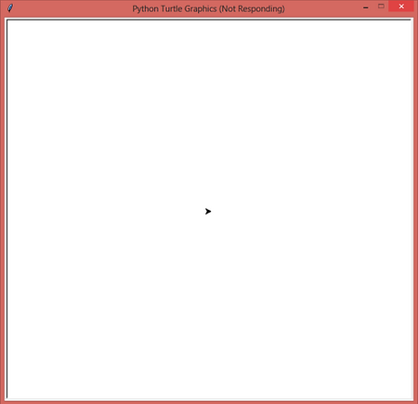

The canvas can be thought of as a graph having the origin(0,0) at its very centre. The centre is called home. That way we can assume that the canvas is divided into four quadrants.

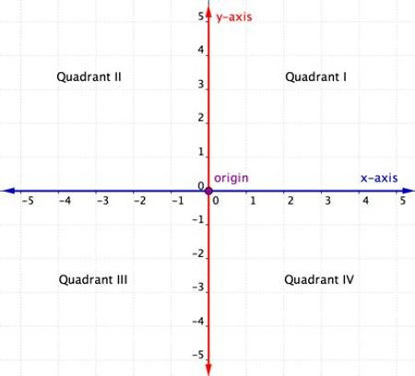

The turtle is a cursor that moves over the canvas following the instructions from the user. Initially it rests at home. When given a command **turtle.forward(20)**, it moves **20 units** in the direction in which it is pointing while drawing a line. When given a command **turtle.left(90)**, it will rotate **90 degrees** in the left direction while still being in-place. By using many other commands as mentioned above we can design many shapes and images easily.

Below are some of the commands that we will be using in the program code:

* **turtle.reset()**: It deletes the drawings of the turtle and sends the turtle back to home and sets everything to default.
* **turtle.write(arg*,* move=False*,* align="left*",* font=("Arial", 8, "normal"))***: I*t writes the string passed in arg on the screen. The text can be formatted with align (“left”, “centre” or right”)andfont(style,size,(“normal”,”bold”,”italic”))*.* If move is true, the pen is moved to the bottom-right corner of the text. By default, move is False.
* **turtle.pencolor()**: It sets the pencolor. It allows four types of arguments.
* **turtle.pensize(width)**: It sets the thickness of the line drawn.
* **turtle.penup()** or **turtle.pu()**: It pulls the pen up and doesn’t draw while moving.
* **turtle.pendown()** or **turtle.pd()**: It pulls the pen down and draws while moving.
* **turtle.goto(x,y)** : It moves turtle to an absolute position specified by values of x and y coordinates without changing the turtle’s orientation.
* **turtle.forward(distance)** or **turtle.fd(distance)**: It moves the turtle forward in the direction which it is pointing to by the specified distance.
* **turtle.backward(distance)** or **turtle.bk(distance)**: It moves the turtle backward (opposite to the direction in which it is pointing) by the specified distance without changing its orientation
* **turtle.right(angle)** or **turtle.rt(angle)**: It rotates the turtle to its right by the specified angle.
* **turtle.left(angle)** or **turtle.rt(angle)**: It rotates the turtle to its left by the specified angle.
* **turtle.circle(radius, extent=None, steps=None)**: It draws a circle with a given radius and extent. If extent is not given, it draws the entire circle.

Using the above commands we will make the turtle write our name. It's like guiding a blind-folded person to reach his/her destination.

It is better to plan out beforehand on a sheet of paper keeping the coordinates in mind to get a result which looks uniform.

Moving ahead there are two ways to write a text using the turtle.

* The first method is to use turtle.write() function. It is the easier way.
* First we import the turtle library.

import turtle

* Then, we set the colour and style of the text. We use turtle.write() and pass the string containing name.

turtle.color('purple')

style = ('Courier', 90, 'normal')

turtle.write('PRACHI', font=style, align='center')

turtle.hideturtle()

This will print the name string on the turtle screen. The output is given below:

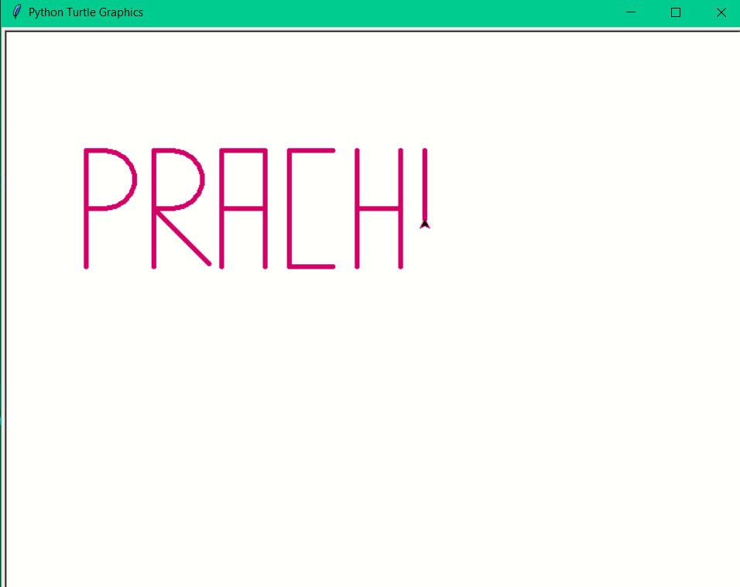

To delete the drawing by the turtle use: turtle.reset()

* The second method requires a lot of planning and hence is a bit tedious, but all the more fun. We guide the turtle to draw.
* First we import the turtle library.

import turtle

* Then we assign the turtle a new name, say 't'.

t = turtle.Turtle()

* Then we set the size and color of the pen and move the turtle (without drawing i.e. wit t.penup() ) to a specific point from where we will start drawing.

t.reset()

t.pencolor('purple')

t.pensize(5)

t.penup()

t.goto(-300,200)

* From here on, we will move the turtle forward, backward, right or left in such a way that we get the desired output. Below is an example to draw the letters 'P' and 'R', though various other codes can be used to produce the same result.

#p

t.pendown()

t.fd(20)

t.circle(-30, 180)

t.fd(20)

t.rt(90)

t.fd(60)

t.bk(60)

t.lt(180)

t.fd(60)

t.penup()

t.goto(-230,200)

#R

t.pendown()

t.lt(90)

t.fd(20)

t.circle(-30,180)

t.fd(20)

t.rt(90)

t.fd(60)

t.bk(60)

t.lt(180)

t.fd(60)

t.bk(60)

t.lt(45)

t.fd(80)

t.rt(45)

t.penup()

t.goto(-160,200)

* This way we write all the other letters of the name.

The output for the full name is given below:

